IOT BASED SMART WATER MANAGEMENT

A Project report submitted in partial fulfilment of the requirements for the degree of B. Tech in Information Technology

By

PRAVEENA.R- (513221205012)

# Under the supervision of

Professor & HOD

Department of Information Technology

# SMART WATER MANAGEMENT

PHASE 3 : DEVELOPMENT PART – 1

In the present era, IoT provides support for multiple industries which is subjective with smart water management solutions. These solutions preserve the overall maintenance and usage of resources. SCADA stands for Supervisory Control and Data Acquisition regulates water distribution systems. SCADA is installed within the overall system. By integrating [**smart water management using IoT**](https://www.karikala.in/) sensors, controlling leakage is feasible in real-time. A series of equipment like water sensors, IoT water flow meters, valves, and irrigation controllers track different measurements like water pressure, temperature, control of water, etc. The collective data of the IoT smart water management system helps multiple firms to analyze information related to real-time water resources. The IoT-enabled smart water management methodologies eradicate maintenance & operational cost.

**Smart water management using IoT** provides the solution for the firms to regulate water flow by interconnecting smart sensors and smart meters. The main role of the sensors and meters is to collect water flow data and generate analytical water performance reports. With the aid of web dashboards, industries observe the utilization of water.

Smart water management aids to reduce water usage consumed in enormous amounts for different fields like agriculture, production sector, agriculture, etc. It contemplates the multiple practices of farming, agricultural applications, farming, etc. Mostly everyone has started to enforce agriculture software to process the tasks.

Water pollution is one of the biggest threats to all living beings. No wonder there is a huge need to monitor water quality using technology. The article shines a light on what an IoT-based Smart Water Quality Monitoring (SWQM) system is, its five

hardware components and benefits, along with the main challenges in water management.

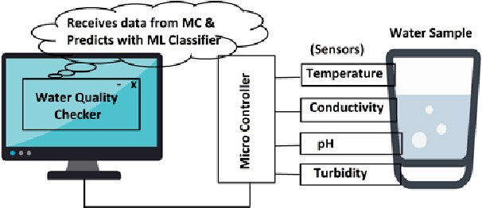

Safe water is rapidly becoming a scarce resource thanks to the combined impact of increased population, pollution, and global warming. Speaking of water pollution, it is one of the biggest obstacles to green globalization.

To ensure the continuous drinking water supply, its quality needs to be monitored in real-time. Traditionally used laboratory-based testing techniques are timeconsuming and costly because they must be undertaken manually.

Even though water monitoring systems have seen some advancement, they utilize the wireless sensor network or wireless network technology that comes with their share of problems, including weakness in data security, communication coverage, and energy consumption management.

That is why the Internet of Things (IoT) has been a boon in this regard, as it enables the current developments of more efficient, secure, and cost-effective systems with real-time capabilities.

SWQM is the process of measuring the water quality parameters, such as temperature, pH, turbidity, dissolved oxygen levels, variety of ions present, and so on. The main objective of monitoring water quality is to ensure these parameters are within a suitable range.

The traditional method of water monitoring was done physically, using only chemicals. A water quality monitoring application involves using different [IoTbased smart sensors](https://www.intuz.com/guide-on-top-iot-sensor-types) that keep track of the parameters in real-time.

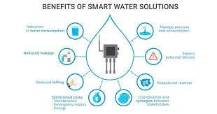

As mentioned previously, the traditional modes of monitoring drinking water quality required manual effort and comprised chemical testing. They were costly and time-consuming and did not have any scope of receiving results in real-time.

However, wireless communication developments soon created new sensor capabilities. In such systems, field technicians would measure a few water parameters on-site using portable sensors, which were easy to transport and use in the field.

Although such a field of sensor networks improved the testing bit to an extent, most of the issues mentioned earlier did not go away. With time, WSN technology gained prominence, allowing receiving feedback on testing in real-time.

However, the network was prone to cyberattacks and had poor data security. The communication speed was low, and the installation and maintenance costs were high.

Sure, the WSN systems were much better than the traditional methods of monitoring of water pollution, but there was scope for improvement.

As IoT allows connected devices to store and exchange data conveniently, the technology has found a way to contribute to environmental issues besides the automation industry. Today, it incorporates some mechanism for monitoring the quality of water over a period of time.

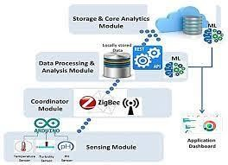

Drinking water is more precious and valuable for all the human beings so the quality of water should be monitored in real time. Some water quality detection parameters are temperature, pH, turbidity, conductivity, dissolved oxygen (DO), chemical oxygen demand (COD), biochemical oxygen demand (BOD), ammonia nitrogen, nitrate, nitrite, phosphate, various metal ions and so on. The most common method to detect these parameters is to collect samples manually and then send them to laboratory for detecting and analyzing. This method wastes too much man power and material resource, and has the limitations of the samples collecting, long-time analyzing, the aging of experiment equipment and other issues. Sensor is an ideal detecting device to solve these problems. It can convert sensor information into electrical signals. It can easily transfer process, transform and control signals, and has many special advantages such as good selectivity, high sensitivity, and fast response speed and so on. According to these characteristics and advantages of sensors, monitoring of Turbidity, PH & Temperature of Water is designed and developed. The measured values from the sensors can be processed by the core controller finally, the sensor data can be viewed on internet using IOT

environment using Zigbee protocol and data from the core micro controller which can be interfaced with multiple sensors at a given time.

This section explains the complete block diagram of the proposed system. Also, it presents the detail explanation of each and every block. The overall block diagram of the proposed system is as shown in figure 1. This proposed block diagram consist number of devices having respective sensors, and the collected data from all devices are gathered at the core controller via Zigbee protocol IEEE 802.15.4. Taking close look of the device, which shown in figure.1. The device consist several sensors for measuring water quality parameter such as pH, turbidity, water level, temperature. The data of sensors are not in a proper manner for sending them directly to the core controller using Zigbee protocol. So, the microcontroller is introduced in a proposed system for getting data from sensors and processes on them to make compatible for Zigbee module. Zigbee has low data rate, low power consumption, more node density that makes it suitable for sensor networking in the proposed system. A Zigbee module consists router Zigbee, which located on all devices that transmit the processed data to the coordinator Zigbee, which collects data from devices connected in the same network. The router Zigbee and coordinator Zigbee are connected in same network using a same PAN ID (personnel are network) for all Zigbee devices in the network. The PAN ID provides the personal area network for wireless data communication

for sensor networking. Coordinator Zigbee is connected to the core controller, the core controller manages data coming from different devices. The core controller puts the data in a text file which is transmitted to the IOT module. For transmitting data to the IOT, gateway is created on the core controller using FTP (file transfer protocol) protocol. The brief introduction of IOT module is discussed in further. In the proposed system,to monitor processed data on the internet cloud computing technology is use which provides the personal local server. In cloud computing, separate IP address is provided which make possible to monitor data from anywhere in the world using the internet. To access that monitor data and make system user-friendly browser application is introduced which work on HTTP. So, by using browser application user can access and monitor the data from all over the world.

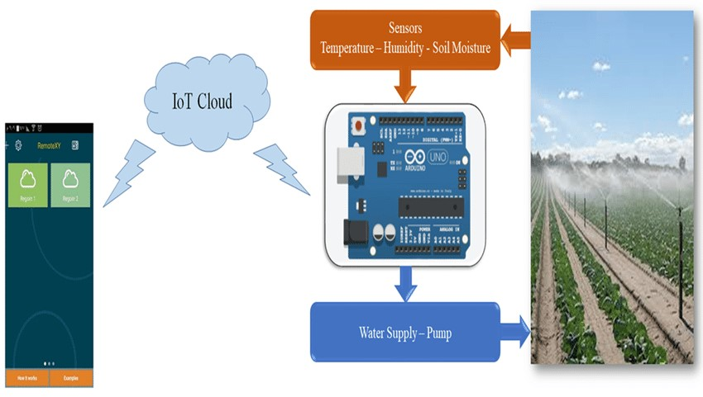

## PYTHON

he above one is also roughly the descending order in which the contribution is made to overall fresh water requirements of the city. In addition to this, people make use of borewells and private tankers for their water needs.

Recently (July 2019), Chennai is facing an acute water shortage due to shortage of rainfall for the past three years (This is the same city which witnessed one of the worst floods in history in 2015). Increasing urbanization has also have caused some encroachment on water bodies in and around the region. As a result, the water in these resources are depleting along with the groundwater level.

Through this blog, we hope to identify any trends in the various data we have collected and have tried providing some visualizations to see how dire the situation is. We also aim to predict the future trends in rainfall and water levels.

### Importing Libraries

import pandas as pd import numpy as np import math

import matplotlib.pyplot as plt import matplotlib.patches as mpatches import datetime import seaborn as sns import plotly.graph_objs as go import plotly.express as px

from plotly.offline import download_plotlyjs, init_notebook_mode, plot, iplot init_notebook_mode(connected=True)

%matplotlib inline

from IPython.display import display import statsmodels.api as sm from pylab import rcParams

from statsmodels.tsa.stattools import adfuller import itertools

colors = plt.rcParams['axes.prop_cycle'].by_key()['color']

### output

Python is a general-purpose programming language with many powerful open-source libraries for research computing. This will be a beginner tutorial describing how to set up the scientific Python environment on your computer and perform common research tasks in hydrology and water management.

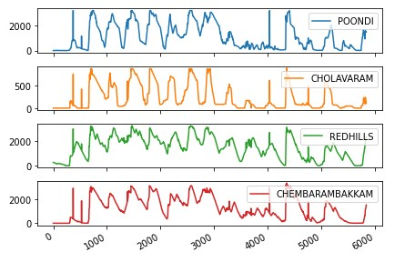

Through this blog, we hope to identify any trends in the various data we have collected and have tried providing some visualizations to see how dire the situation is. We also aim to predict the future trends in rainfall and water levels.